DANGER INFECTIOUS WASTE  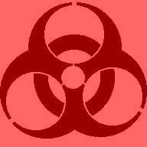 |  | DANGER INFECTIOUS WASTE
DANGER INFECTIOUS WASTE |  | DANGER INFECTIOUS WASTE
DANGER INFECTIOUS WASTE |  | DANGER INFECTIOUS WASTE

